16.61: The wavelength is twice the separation of the nodes, so
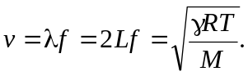
Solving for 